5th Lab – 7 Segment Display Control Using AT89C51

Implementation:
Keil:
Open Keil µVision → Go to Project → New µVision Project → Set a project name and save it → In the Select Device for Target window, search and select AT89C51 → Click OK → When prompted, click No → In Project window, right-click Source Group 1 under Target 1 → Select Add New Item to Group 'Source Group 1' → Create and save a new C file → Write the code below and save:

Source Code:
#include <reg51.h>
void Delay(int timer)
{
int i, j;
for (i = 0; i < timer; i++)
{
for (j = 0; j < 1275; j++)
{}
}
}
void main()
{
char number[] = {0x3F, 0x86, 0x5B, 0x4F, 0x66, 0x6D, 0x7D, 0x07, 0x7F, 0x6F};
int i, j;
P2 = 0x00;
P3 = 0x00;
while (1)
{
for (i = 0; i <= 9; i++)
{
P2 = number[i];
for (j = 0; j <= 9; j++)
{
P3 = number[j];
Delay(50);
}
}
}
}
→ Right-click Source Group 1 → Add Existing Files to Group → Select the saved .c file → Click Add and Close → Right-click Target 1 → Options for Target → Go to Output tab → Check "Create Hex File" → Go to Target tab → Set Xtal (MHz) to 11.0592 → Click OK → Press F7 to build the project → If there are no errors or warnings, your code is okay.

Proteus:
Open Proteus → Click New Project → Set project name → Keep clicking Next until Finish → Click Finish → From the left sidebar, select Component Mode → Click P → Search and add AT89C51 → Add 7SEG-COM-CAT-GRN ×2→ From the sidebar, select Terminals Mode → Add Ground
Component Placement:
Click P → Add AT89C51 & 7SEG-COM-CAT-GRN ×2 → Place on workspace.
Wiring:
Connect P2.0–P2.6 to first 7-segment → Connect P3.0–P3.6 to second 7-segment → Connect common cathodes to GND.
Programming:
Double-click U1 → Set clock frequency = 11.0592MHz → Browse and select U1's HEX file → Click OK
Simulation:
Click the Play button → Observe: First display counts 0–9, second display counts 9–0 → Save the project

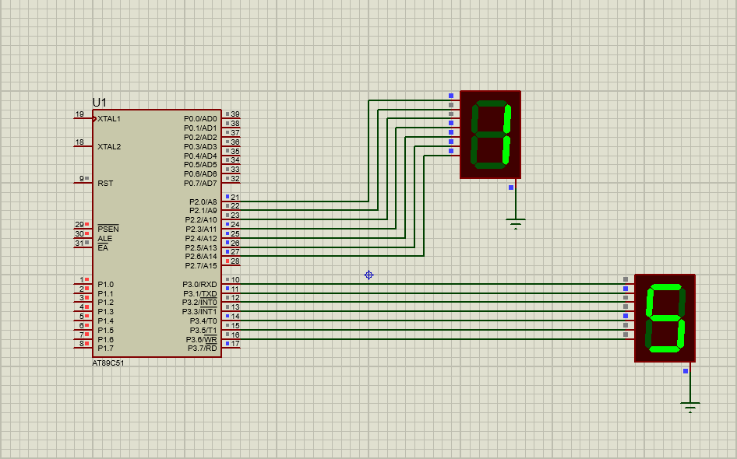
Diagram:

